**INVENTORY MANAGEMENT SYSTEM**

**Project Title:**

**Inventory Management System Using C#**  
**Submitted by:**

**Muhammad Bilal Talib**   
**Course:**

**Visual Programming**

**Instructor:**

**Mam Aatka Ali**

**Submission Date:**

**26-12-2024**

PROJECT REPORT

Introduction:

This project aims to develop a WPF-based application for managing sales, inventory, and orders. It includes functionalities for product and user management, audit logging, dashboards for statistics, and data printing. The system ensures efficient handling of data with a user-friendly interface.

Objectives:

* To build a robust, feature-rich sales and inventory management system.
* To provide key insights through dashboards and audit logs.
* To streamline CRUD operations for products, categories, suppliers, and sales.

System Features

**Loading Form:**

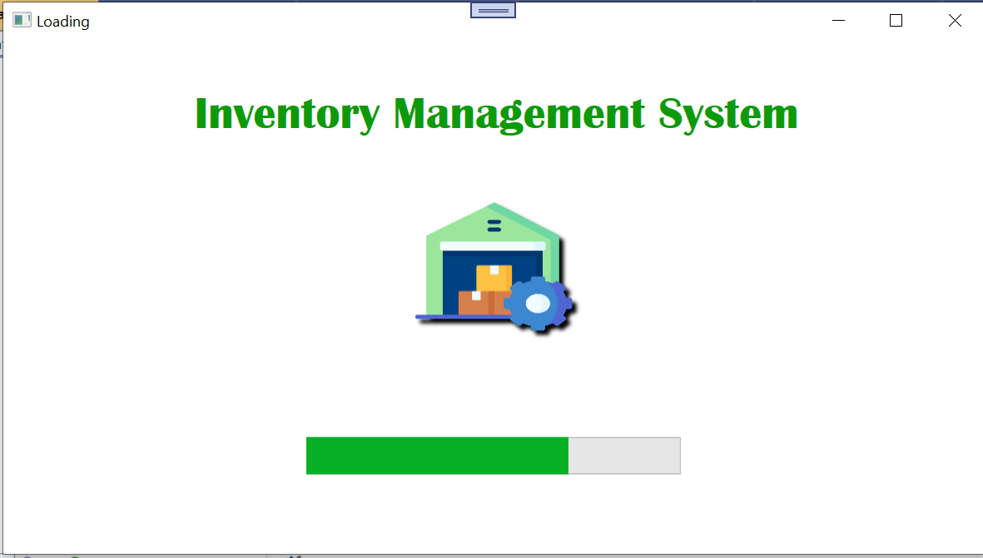

**Authentication Module:**  
Secure user authentication with a login system (Username, Password)

Role-based access through signup functionality (Username, Password, Role).

**SignUp:**

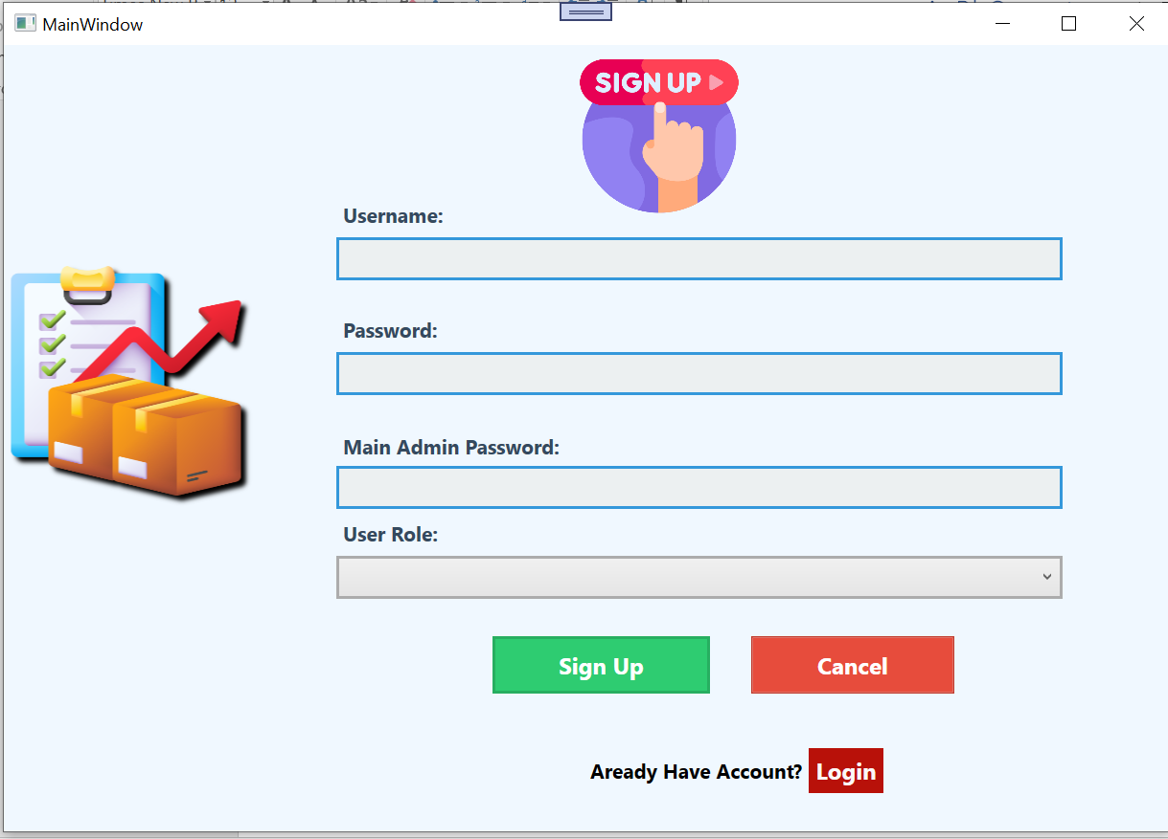

**LOGIN:**

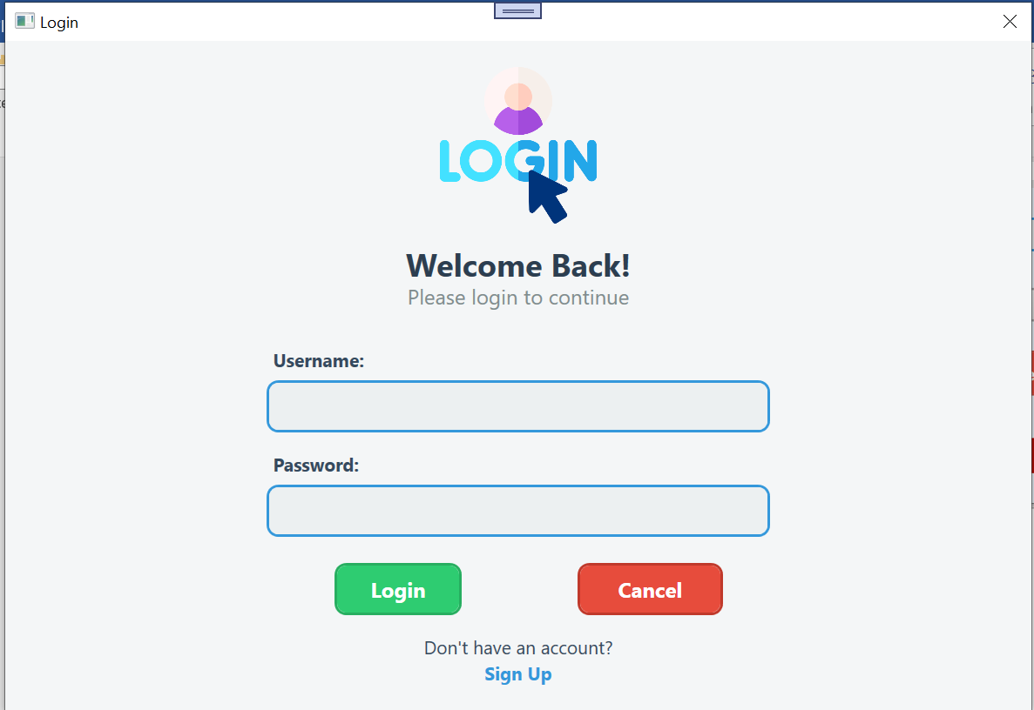

**Frontend Design:**  
Offers an intuitive, user-friendly interface with modern design elements for seamless navigation and operation.

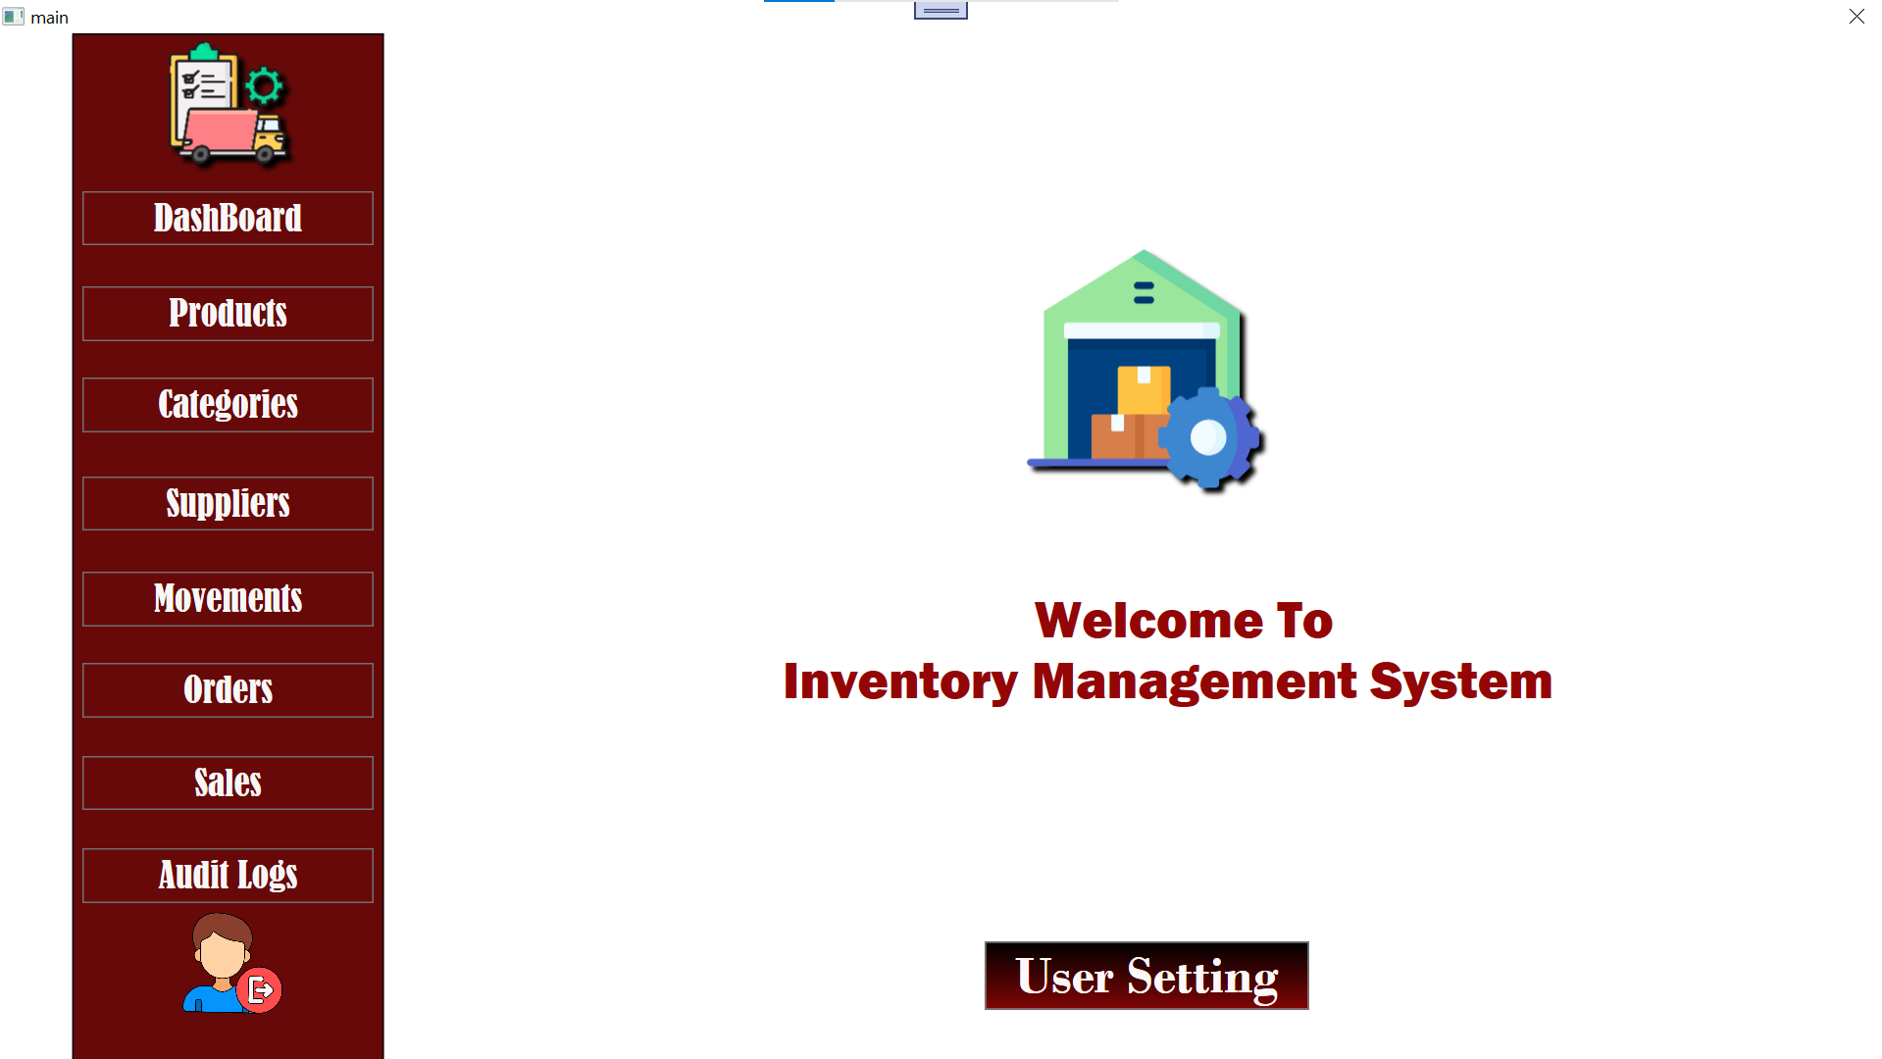

**Dashboard:**  
Provides real-time insights with key statistics such as total sales and user counts displayed in a visually appealing manner.

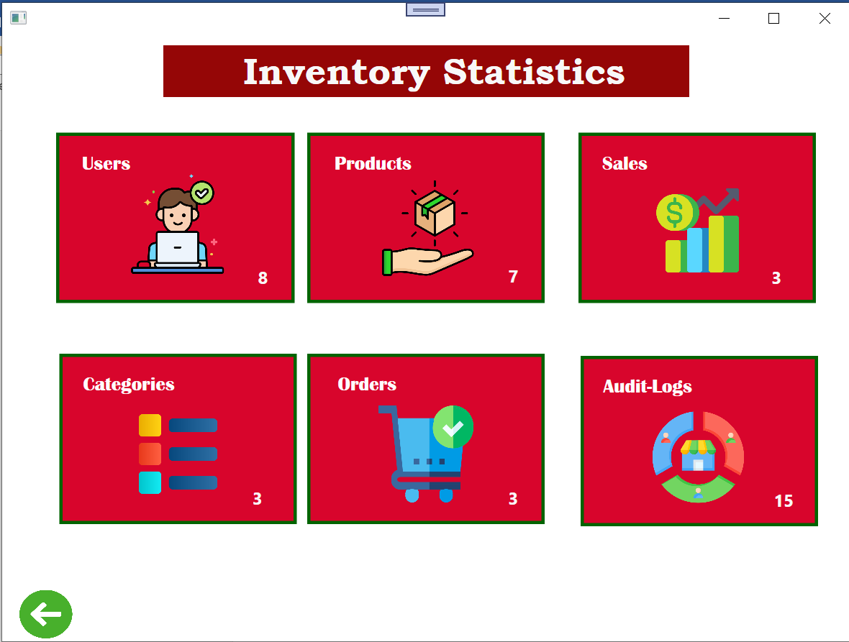

**Products Management:**  
Enables adding, updating, deleting, and loading of product details, ensuring efficient inventory handling.

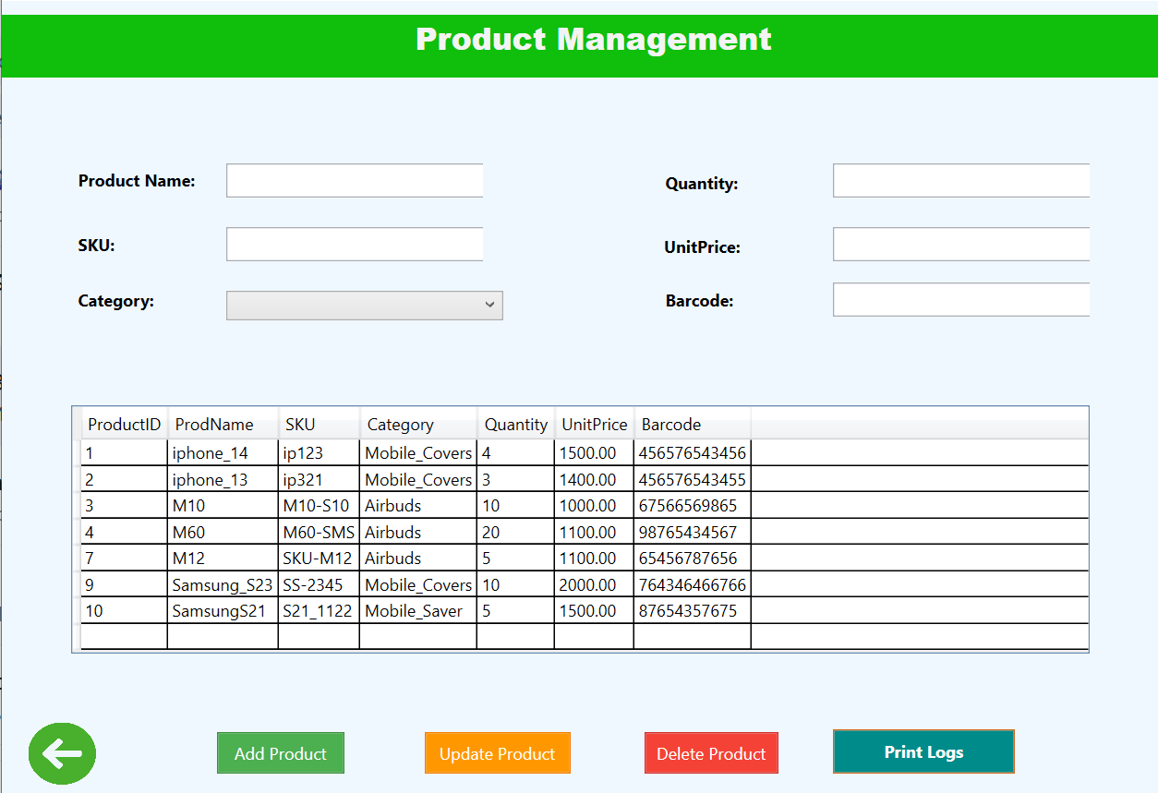

**Categories Management:**  
Allows users to add, update, and delete product categories for better inventory organization.

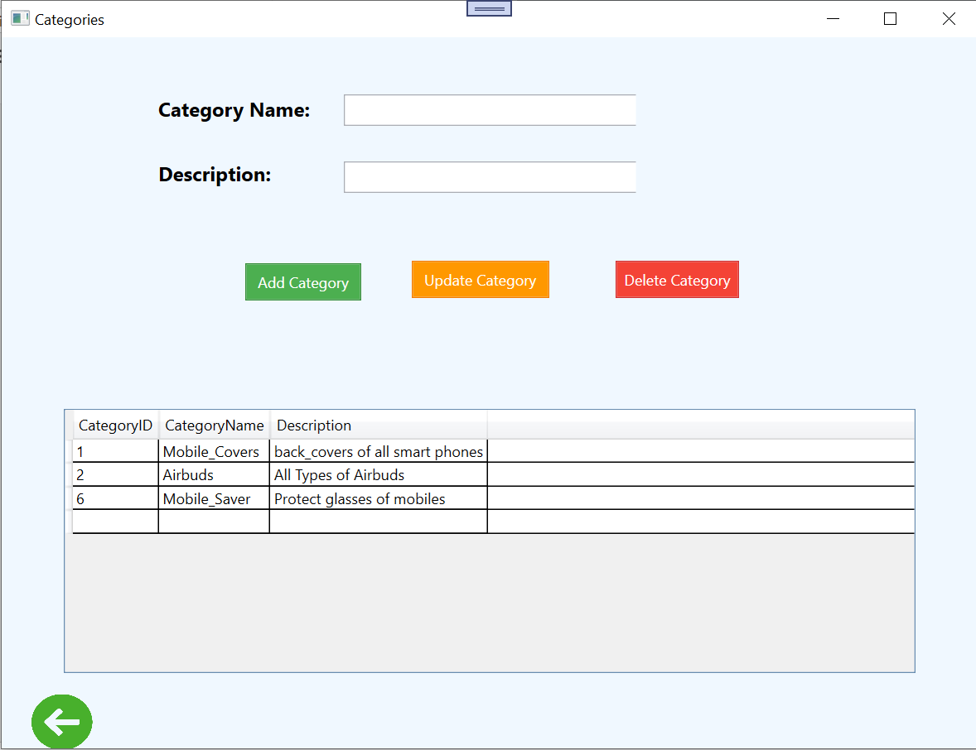

**Supplier Management:**  
Facilitates adding, updating, and deleting supplier information for streamlined supply chain management.

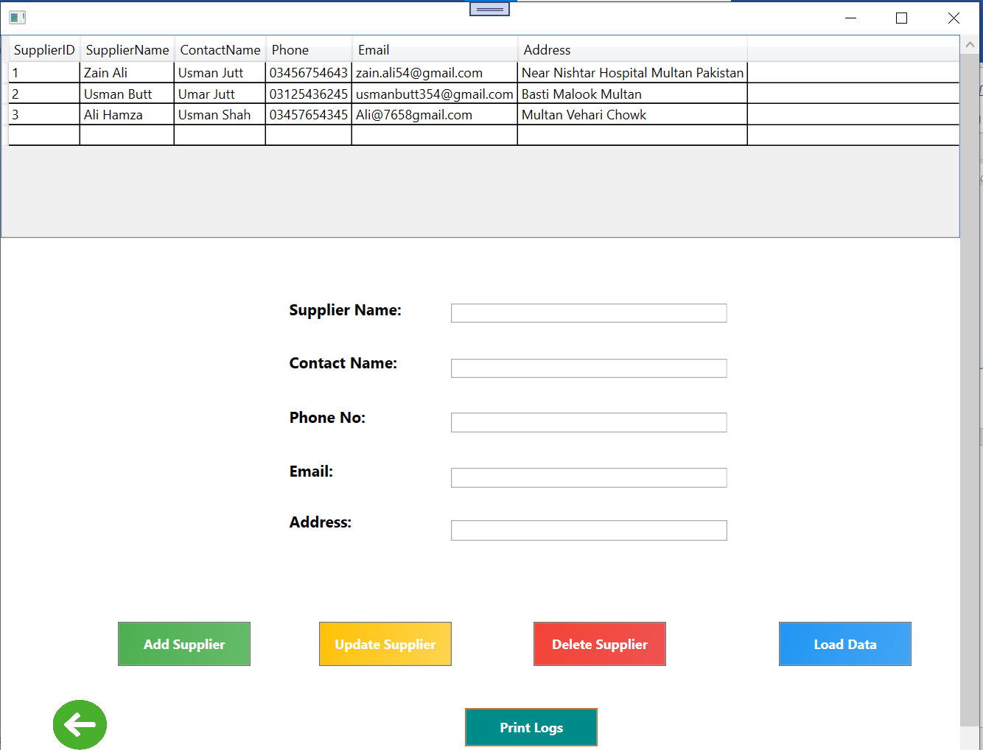

**Movements Tracking:**  
Manages product movements like additions, updates, and deletions, helping to keep records of stock changes.

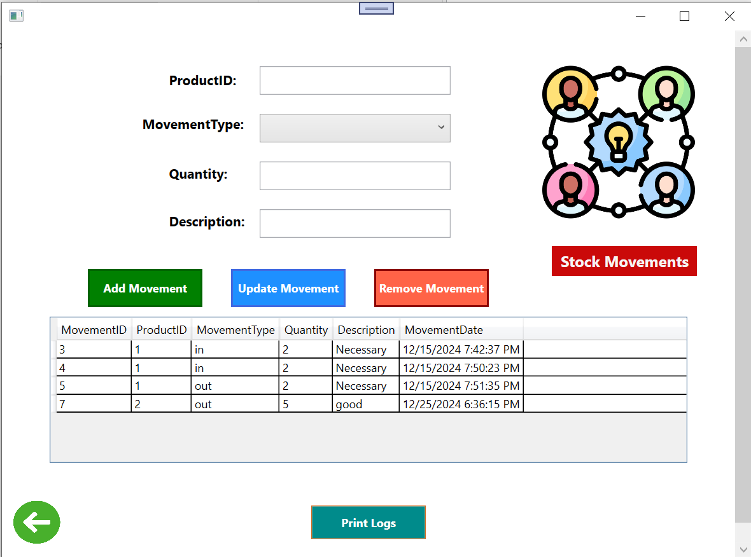

**Sales Management:**  
Supports adding, updating, and deleting sales records while calculating and displaying total profit details.

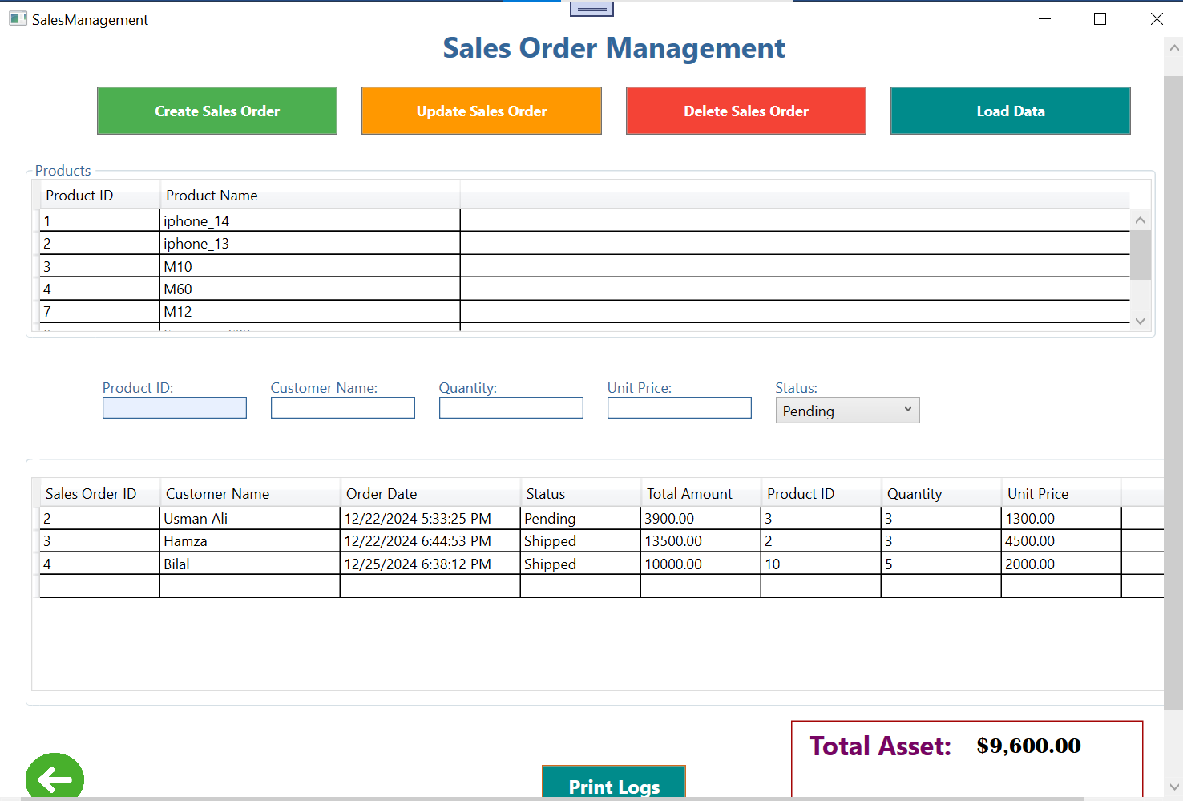

**Order Management:**  
Handles order creation, updates, and deletions to ensure smooth order processing and tracking.

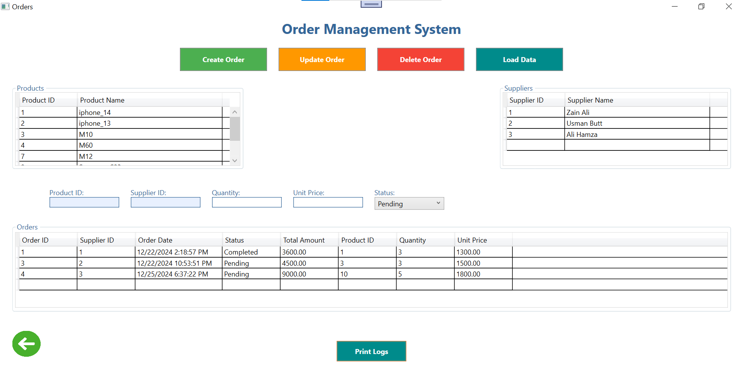

**Database Management:**  
Efficiently stores and manages all project data using a well-designed relational database schema.

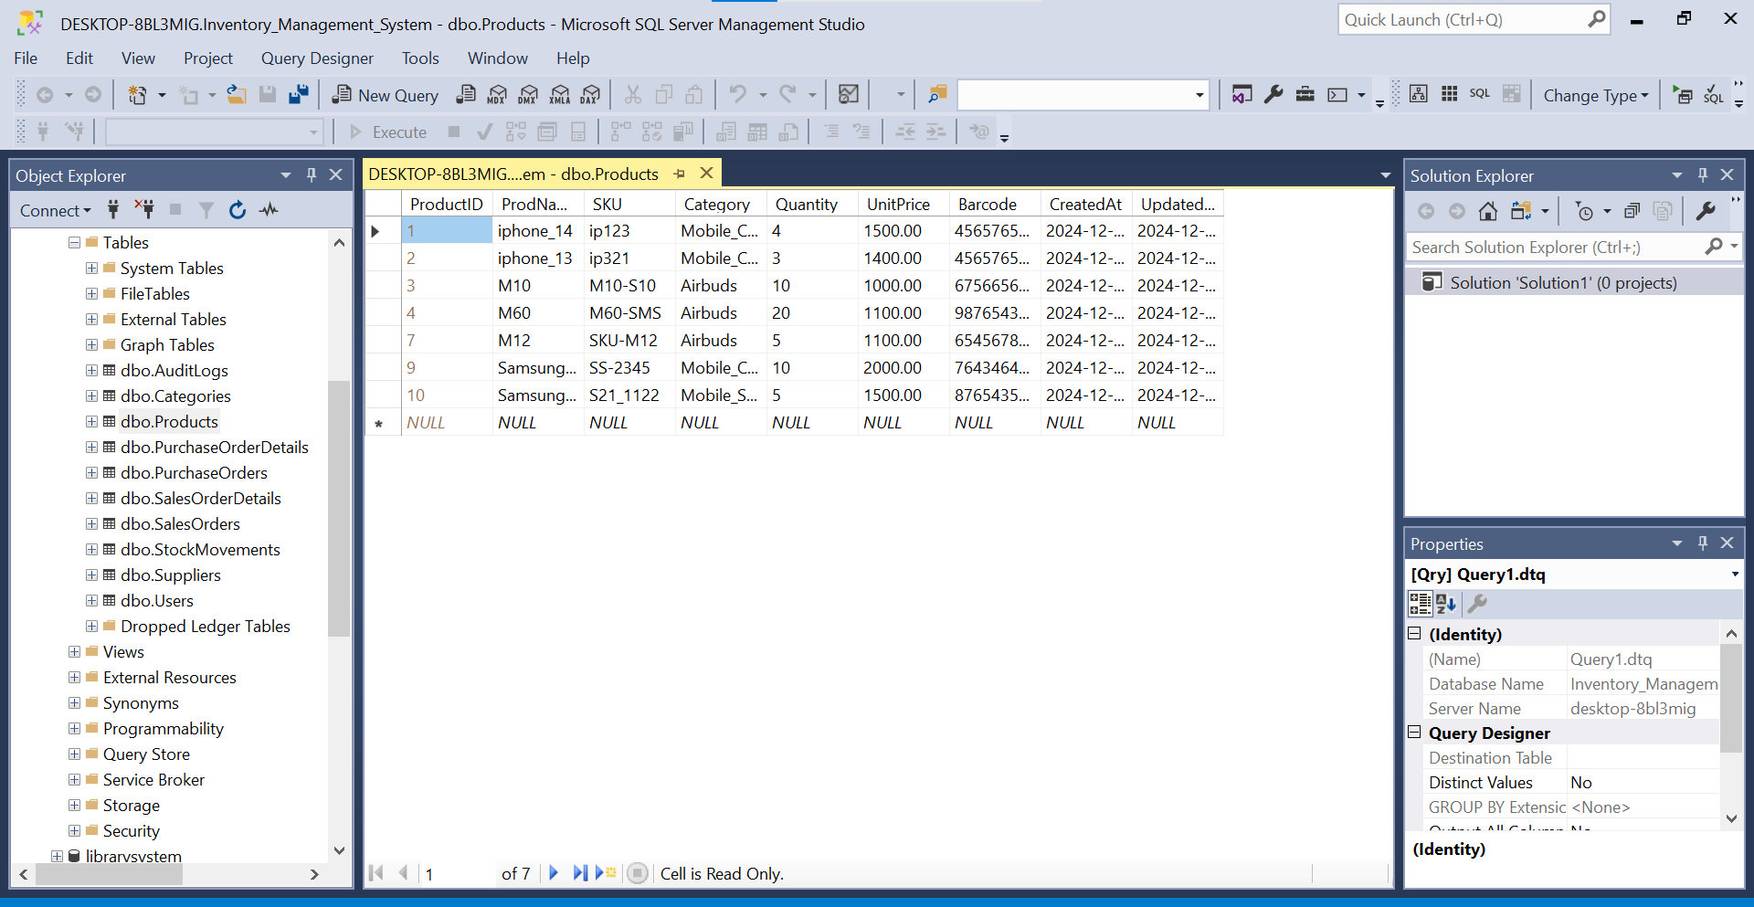

**User Settings:**  
Provides customizable settings to enhance user experience and personalize the system.

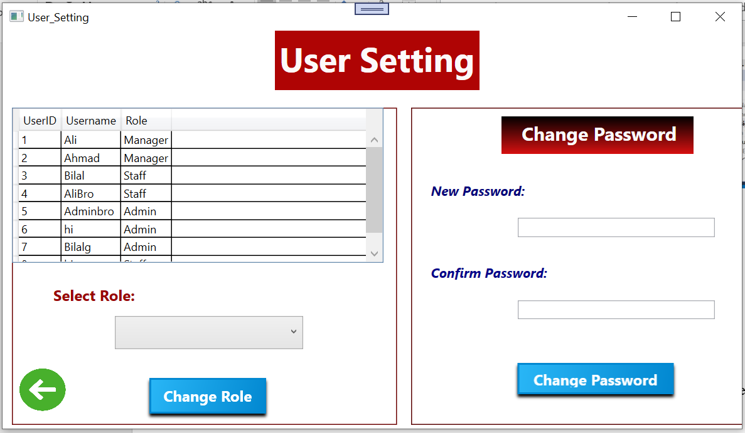

**Data Print Functionality:**  
Generates printable reports and summaries of data for record-keeping and analysis.

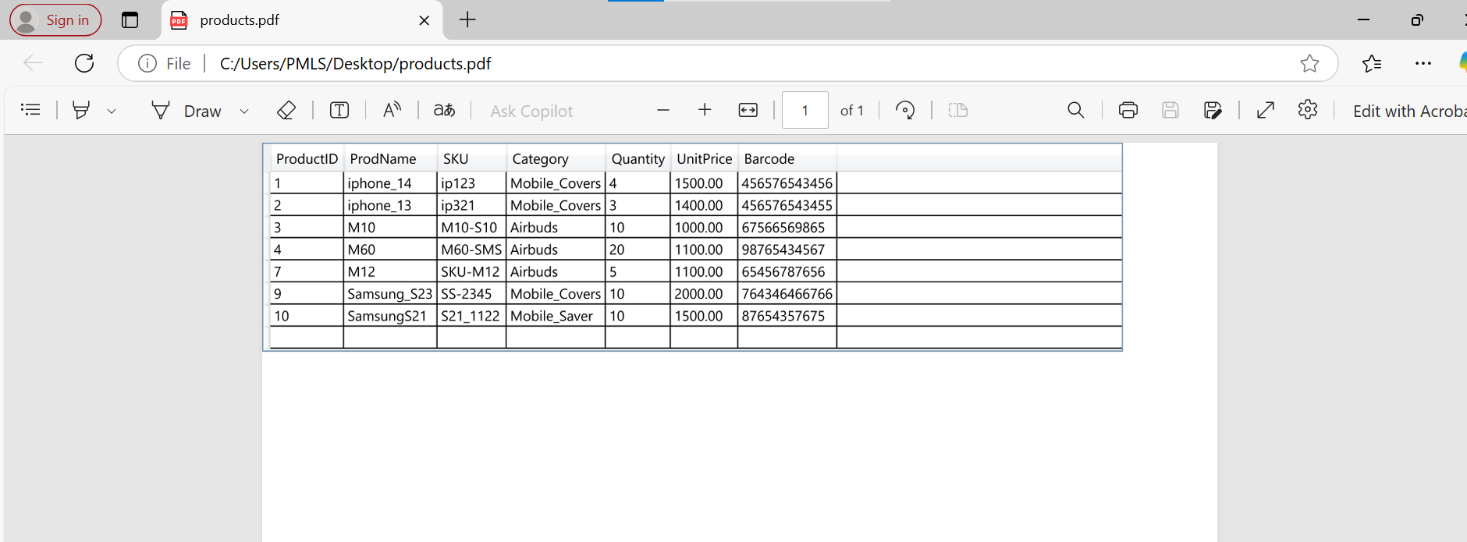

**Audit Logs:**  
Tracks all runtime changes, including updates and deletions, ensuring accountability and easier debugging of the system.

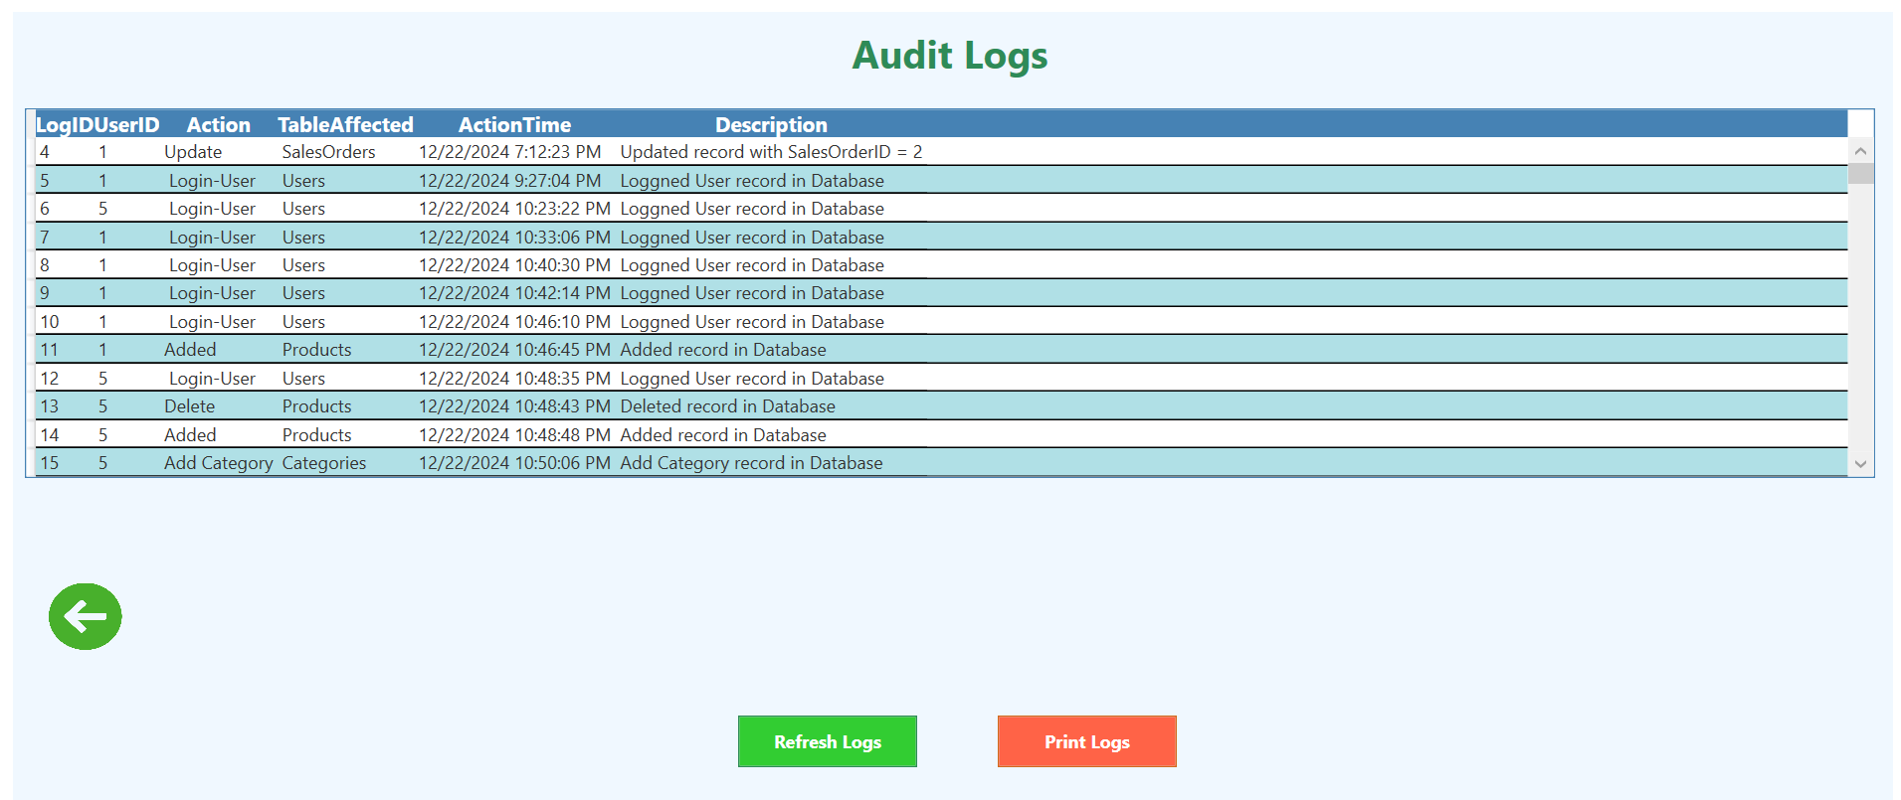

Technologies Used

* **Language:** C#
* **Framework:** WPF
* **Database:** SQL Server
* **Tools:** Visual Studio

Challenges and Solutions

* Describe the difficulties faced during development and how they were resolved. For example:
* Integrating audit logs.
* Ensuring data consistency during CRUD operations.

Testing and Evaluation

* Each module was tested for functional correctness and performance.
* CRUD operations, authentication, and dashboards were verified to ensure seamless operation.

Results

* The system successfully manages sales and inventory, generating accurate statistics and reports. Screenshots of the dashboard and sample printouts demonstrate functionality.

FlowChart

**Sales**

**Audit Logs**

**User Setting**

**Movements**

**DashBoard**

**Products**

**Categories**

**Suppliers**

**Orders**

### Future Enhancements

The system can be enhanced by integrating APIs for real-time updates, improving UI aesthetics, and adding advanced analytics for sales trends and inventory forecasting. Multi-language support and cross-platform compatibility can further broaden its usability and appeal.